# Technical Report: Fleet Management System

## System Architecture

### Data Layer

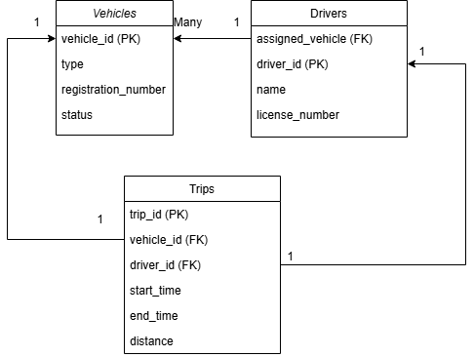

Vehicles: It stores all the details of vehicles. Primary Key is vehicle_id.

Drivers: It stores all the details of the driver. Primary Key is driver_id. Because Driver is only assigned to 1 vehicle only so assigned_vehicle is a foreign key.

Trips: It store all trip details, Primary Key is trip_id. And all trips must have driver and vehicle so vehicle_id and driver_id is foreign key.

### Business Logic and Presentation Layer

Service layer: Allow business user (driver) to record their name and vehicles via app/web. Allow driver to record each trip via app/web or automated. Driver also able to see each trip via app/web. Control tower should be able to track trips and monitor vehicle status by real-time and generate report via app/web.

## Support for Fleet Operations and Resource Utilization

The app/web should be able for fleet manager to track his driver group to monitor the vehicle status, location and trip rating. It will help the fleet manger to know the average performance of the driver.

Also, the data should be able to analysis the usage of the vehicle. For example, management should be able to understand the usage of the vehicle for different time periods. And assign more manpower for peak hour and cut manpower if the usage is low in that time period (e.g. midnight).

## Key Challenges and Proposed Solutions

Data Integrity and Consistency is one of the major challenges. In Hong Kong, the handover of vehicle between shift is very old-school without any documentation. The data may lost or incorrect during the handover. To make sure the accurate of the data, QR code scanning and face recognition via app before the shift and real time data transmission from the meter should be introduced to make sure the actual driver and actual data are recorded.

User adoption is another key challenge. In Hong Kong, the average age of taxi drivers is high which mean that driver may not be willing to accept the new technology. Training should be conduct to driver in order to let them know how to use the system. Also introduce continuous adoption bonus to driver to attract them to use the system in a continuous manner.

## Conclusion

In Hong Kong, introducing new fleet management system will enhance operational efficiency and optimize resource utilization in fleet operations. However, the adoption of the system will be difficult because of the high average age of the taxi driver in Hong Kong.